|  |  |  |  |  |  |  |
| --- | --- | --- | --- | --- | --- | --- |
| **Mehran University of Engineering & Technology,**  **Jamshoro** | |  | **Subject** | | | |
| **Web Technology** | | | |
| **Department of:**  **Bachelor of Science Computer Science** | | **Year** | **2nd** | **Semester** | **3rd** |
| **Roll No:** | **20BSCS043** | **Batch** | **20BSCS** | **Duration** | **3 Hours** |

**PRACTICAL # 11**

**TO MANAGE SERVER-SIDE CONDITIONAL CONTROL STRUCTURES**

**Task # 1:** Make a PHP page which will generate a table of inputted number.

**Code:**

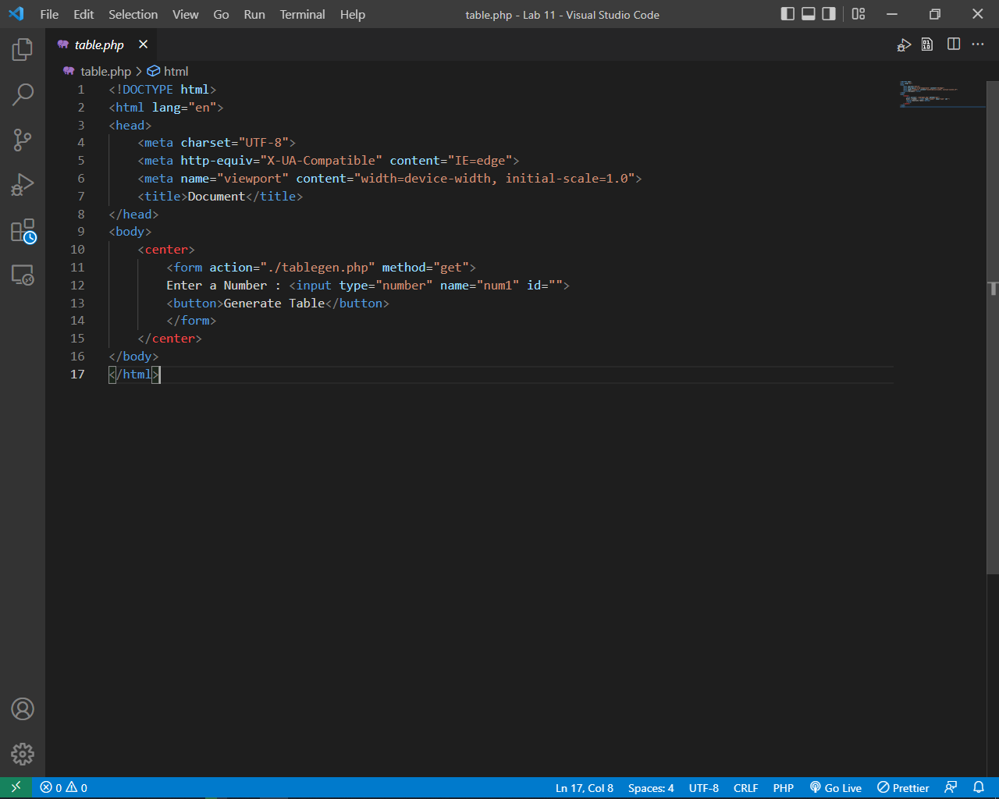

File # 1

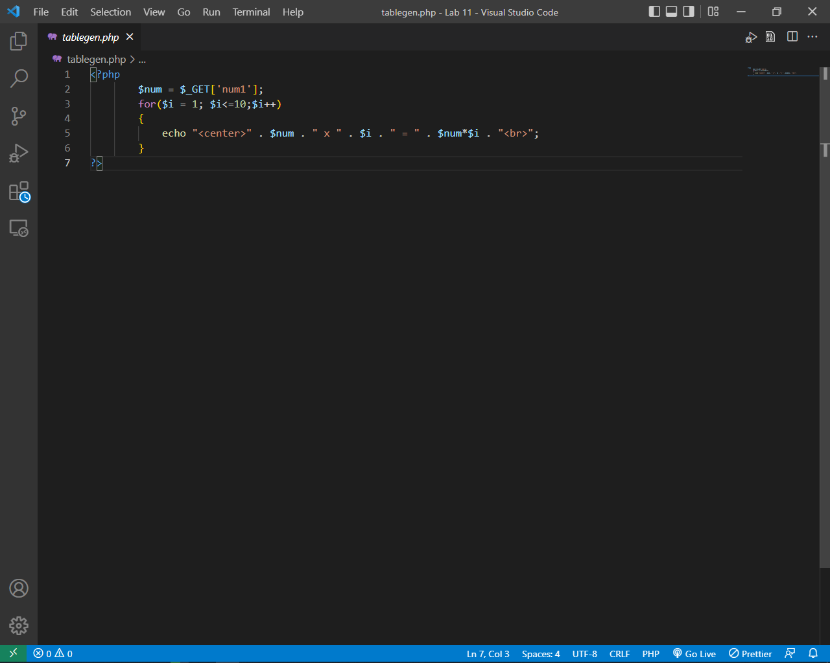

File # 2

**Output:**

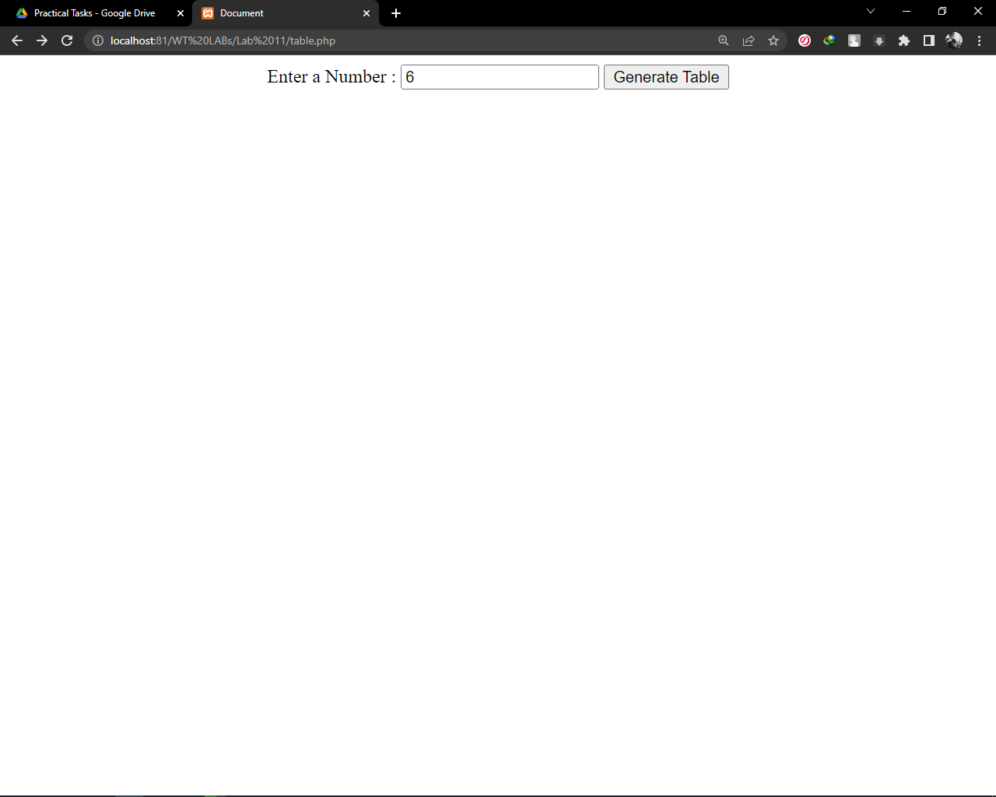

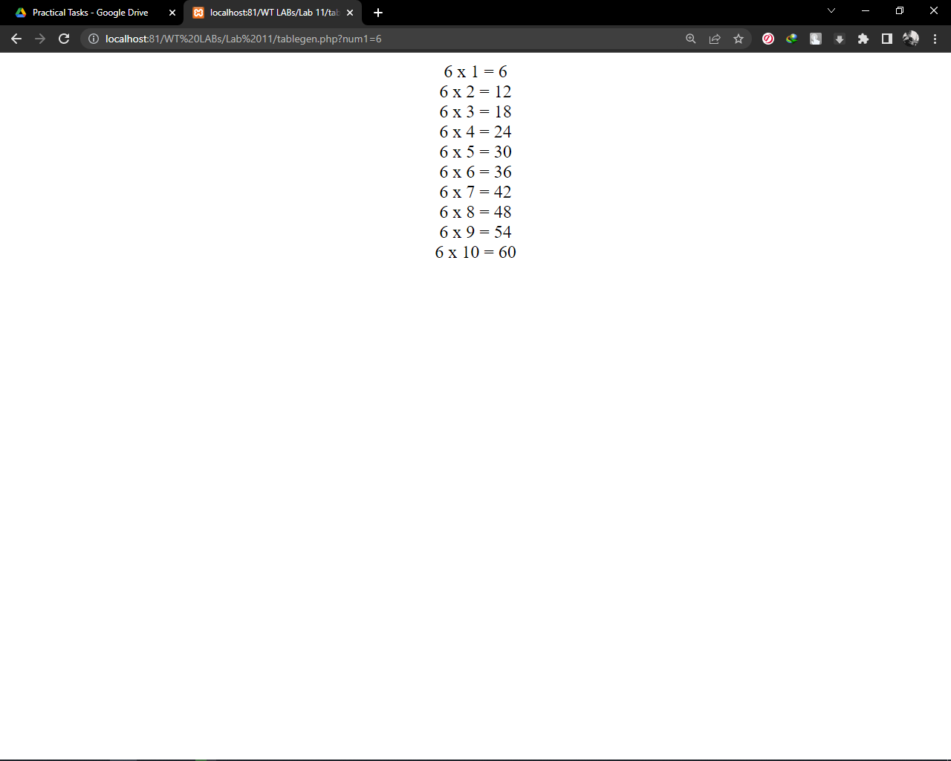

**Task # 2:** Make a PHP page which will show whether the inputted number is even / odd.

**Code:**

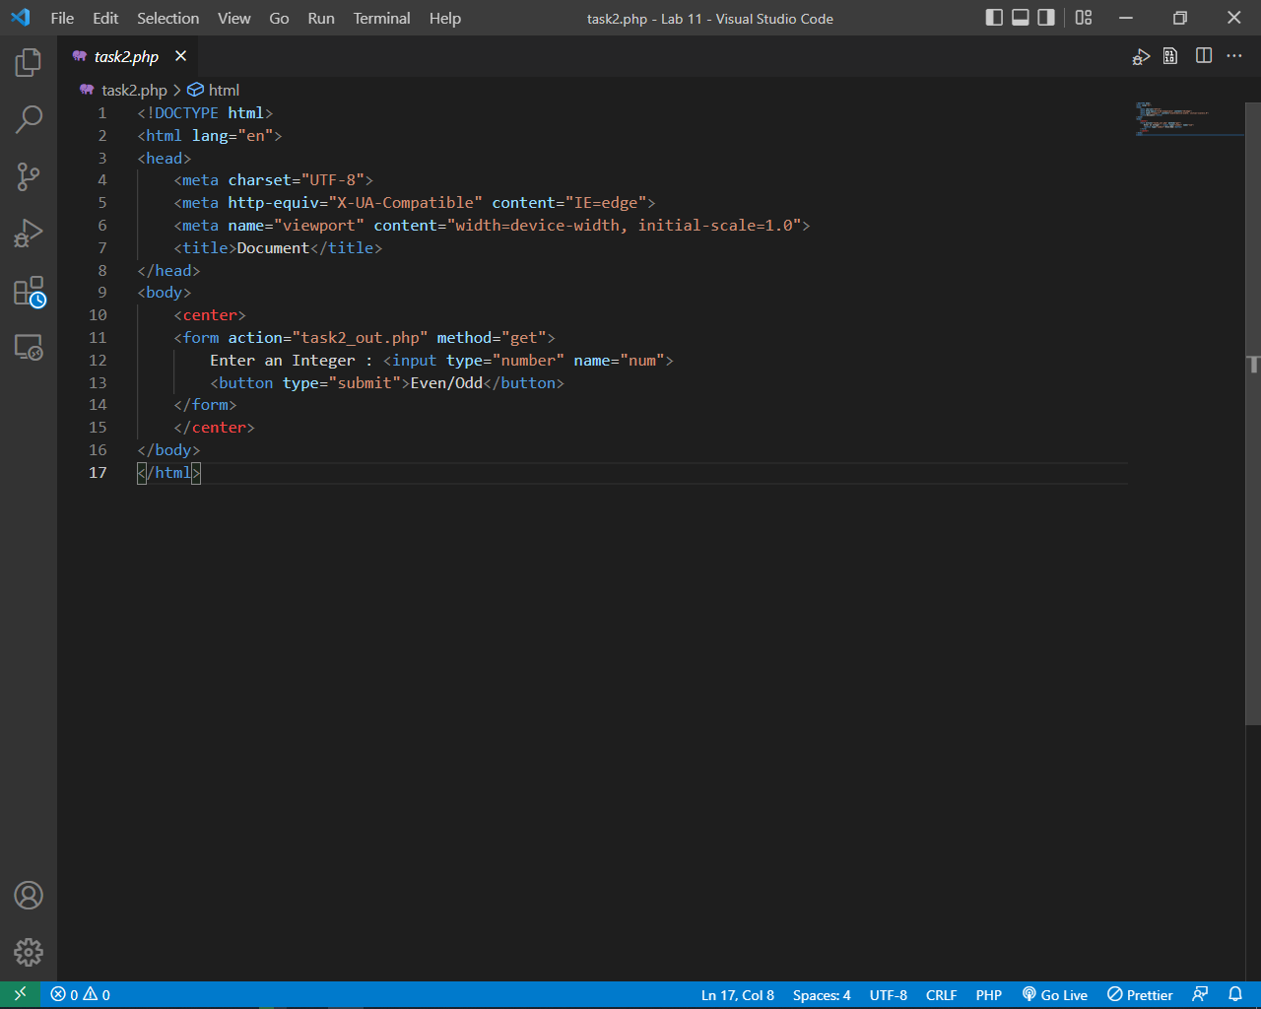

File # 1

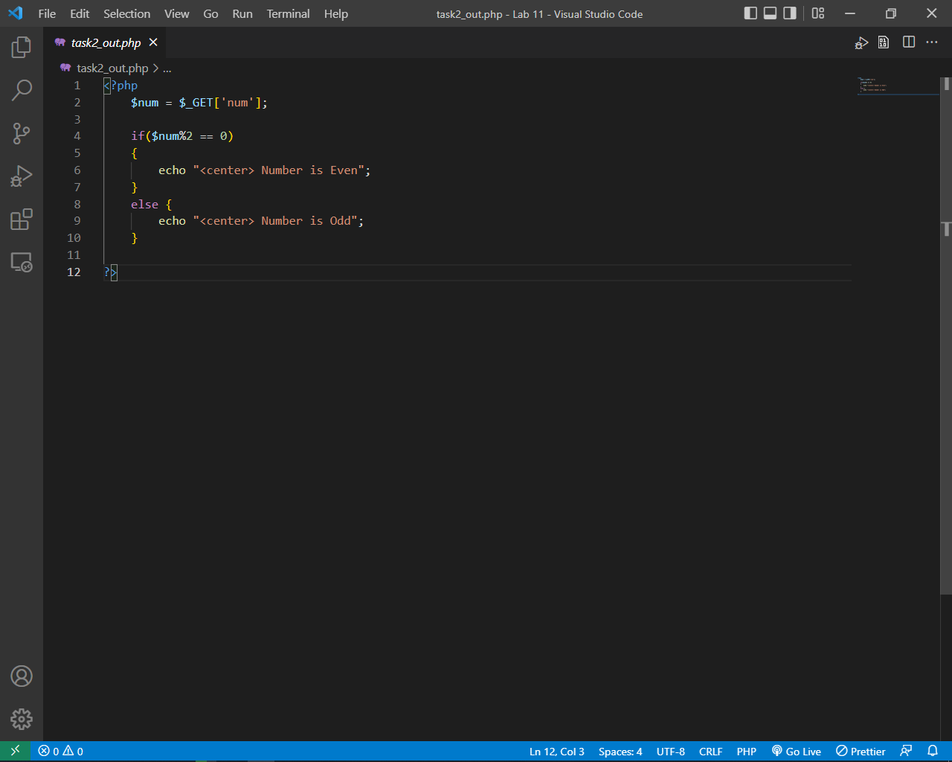

File # 2

**Output:**

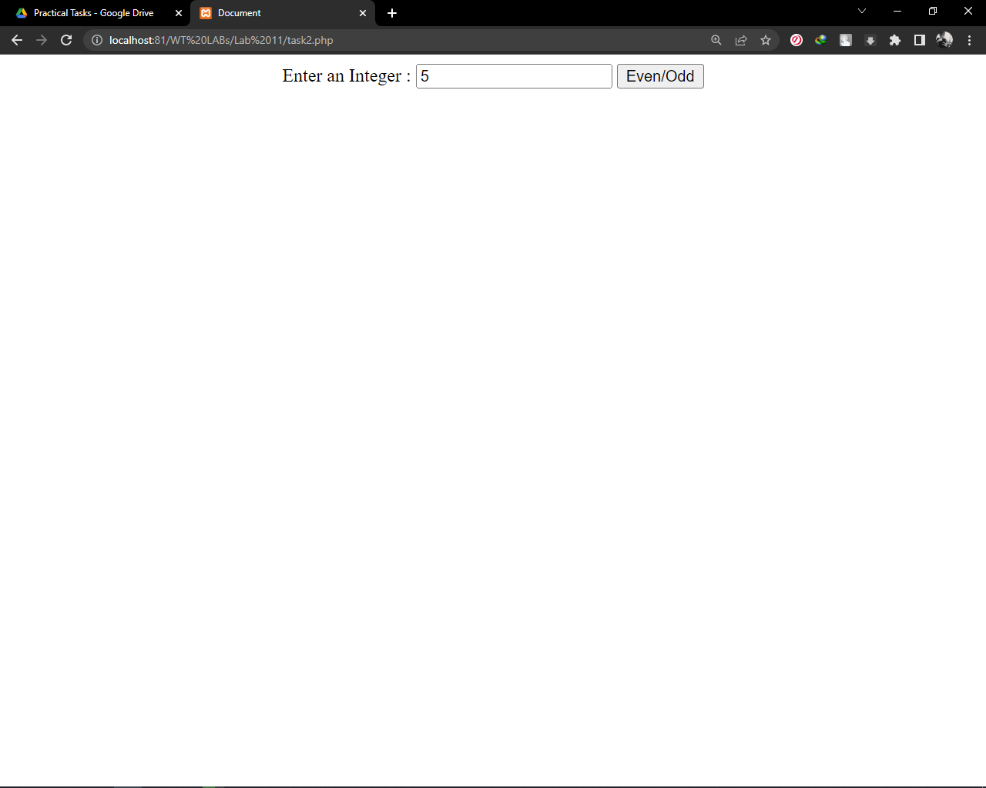

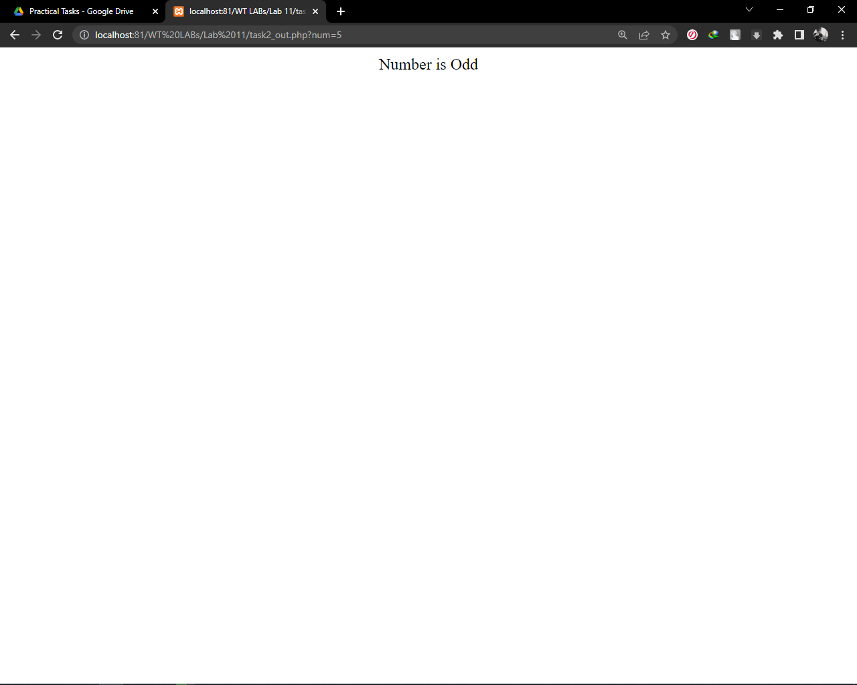

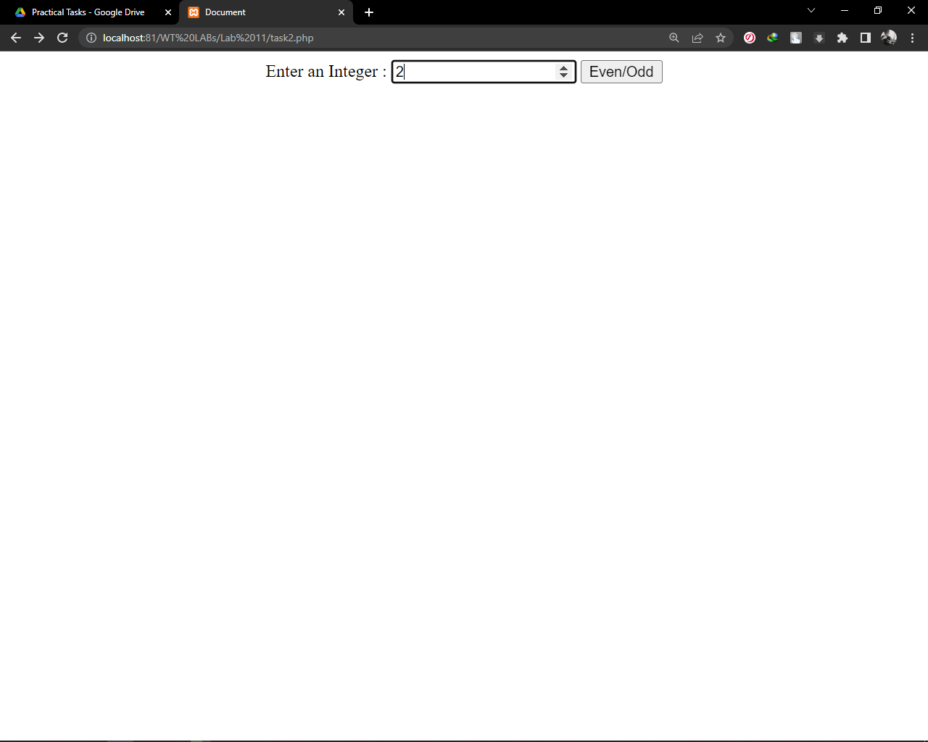

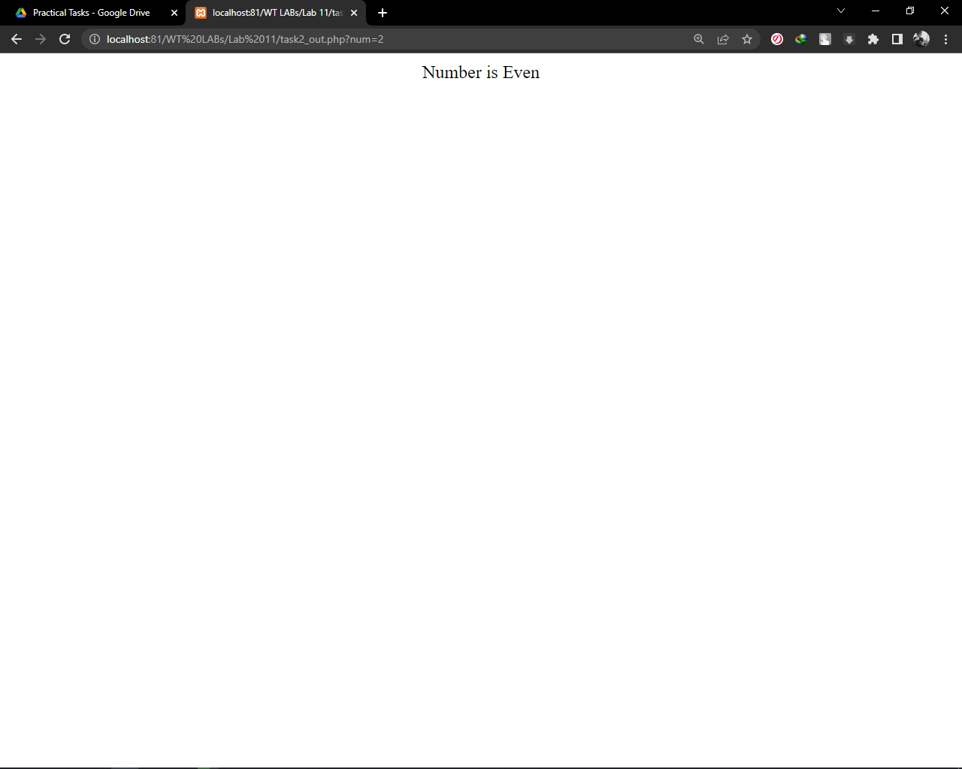

**Task #3:** Create Simple server-side validation form, which will ask username & password. If inputted username should be “Your Roll No” & and password should be “15CS” then it will show you greeting else generate an error.

**Code:**

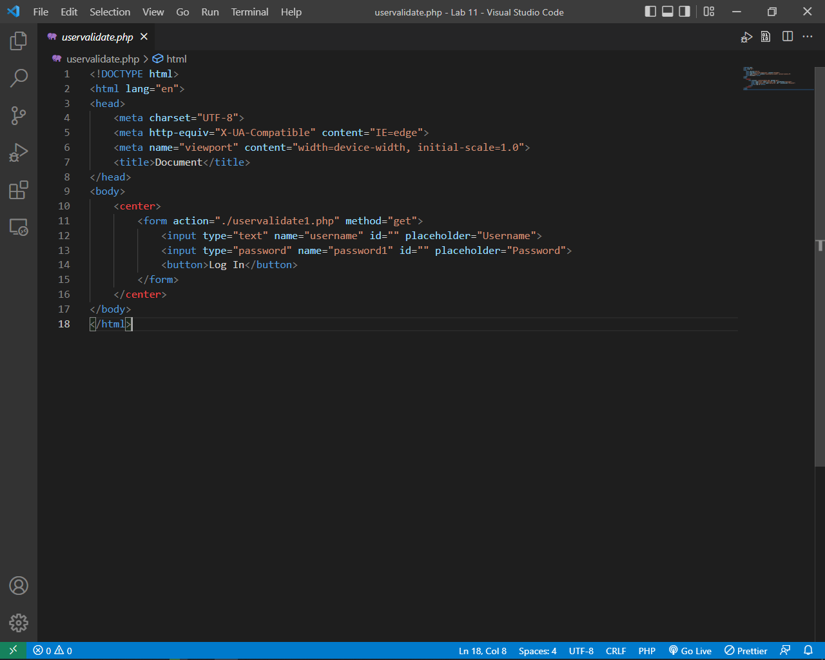

File # 1

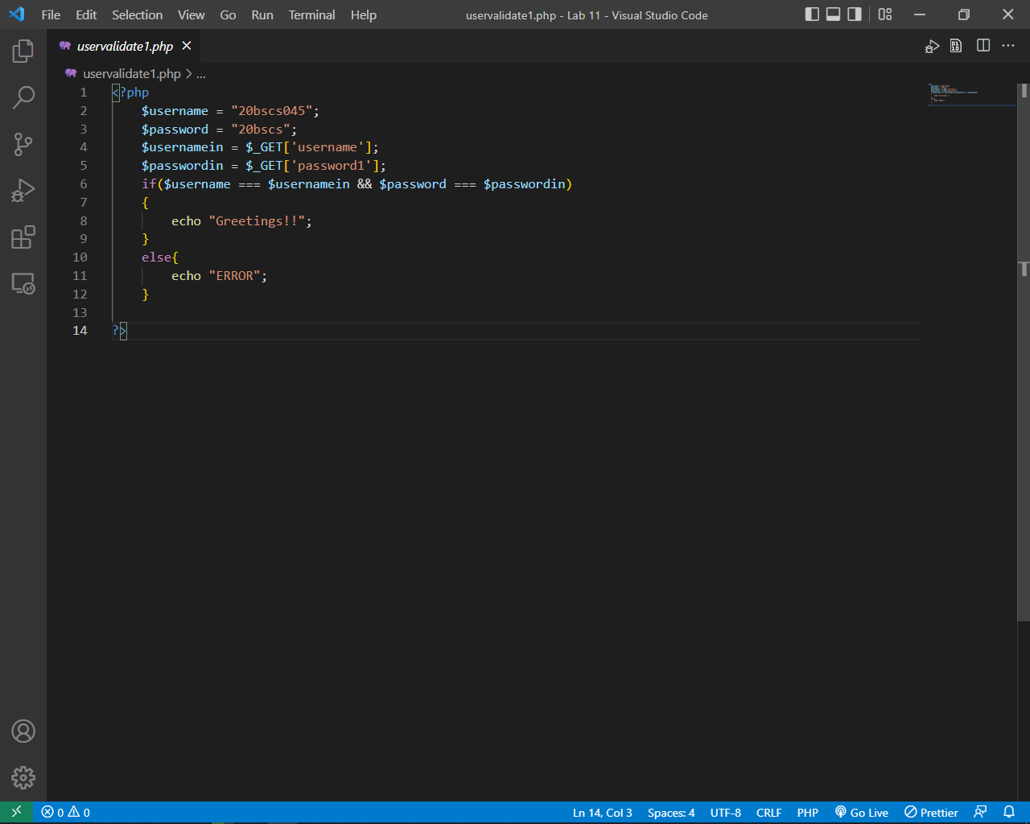

File # 2

**Output:**

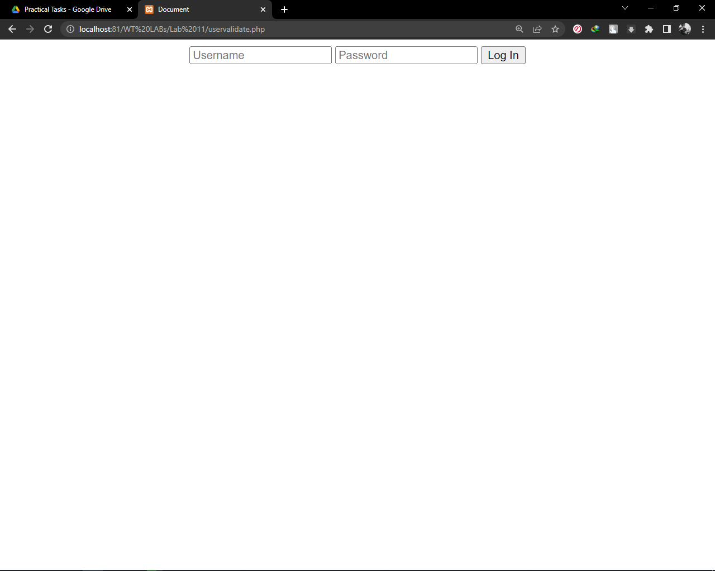

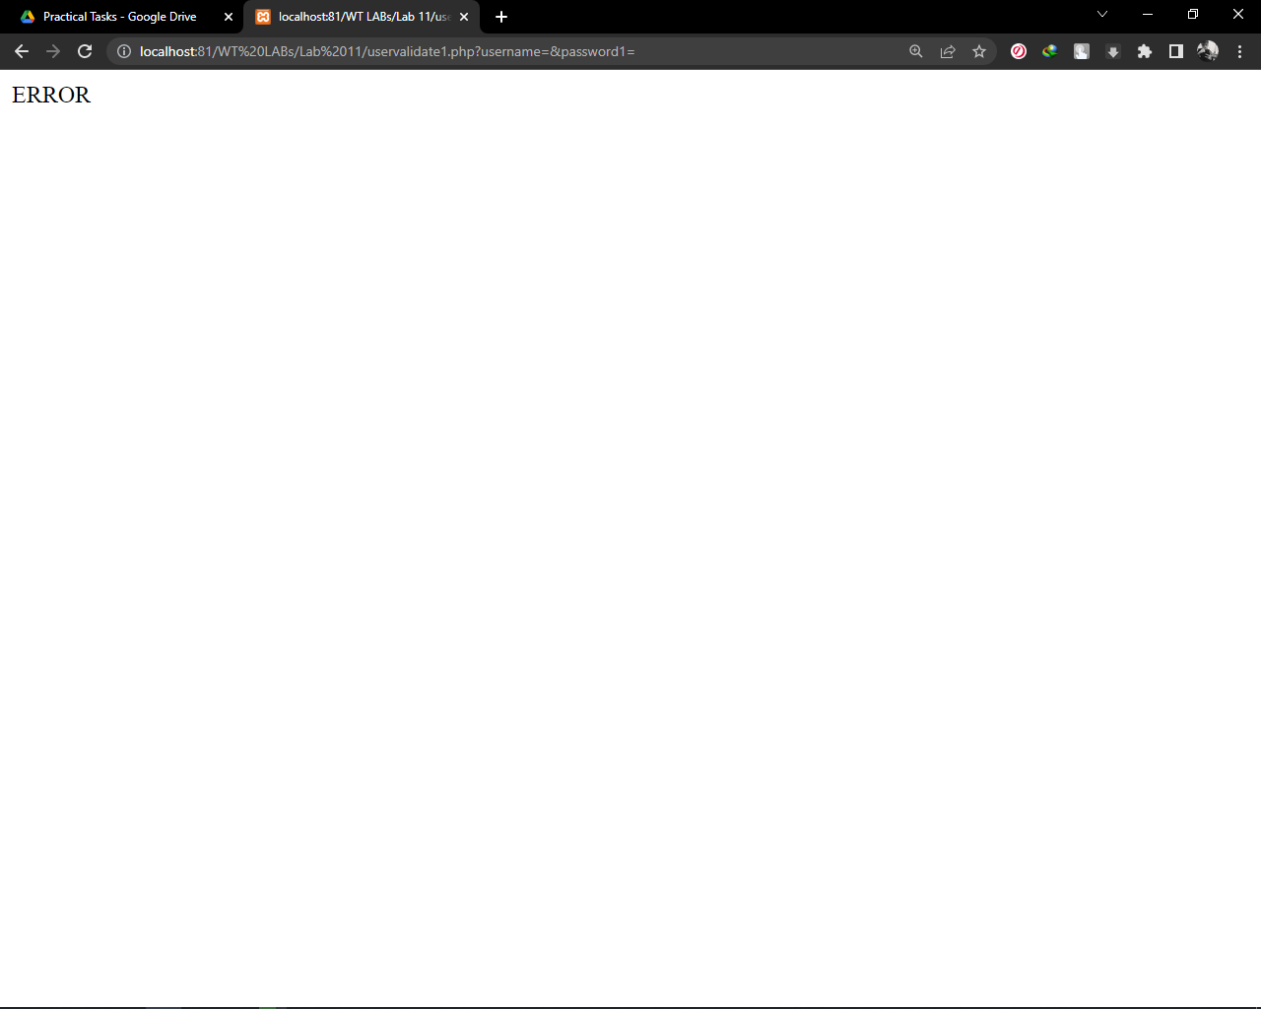

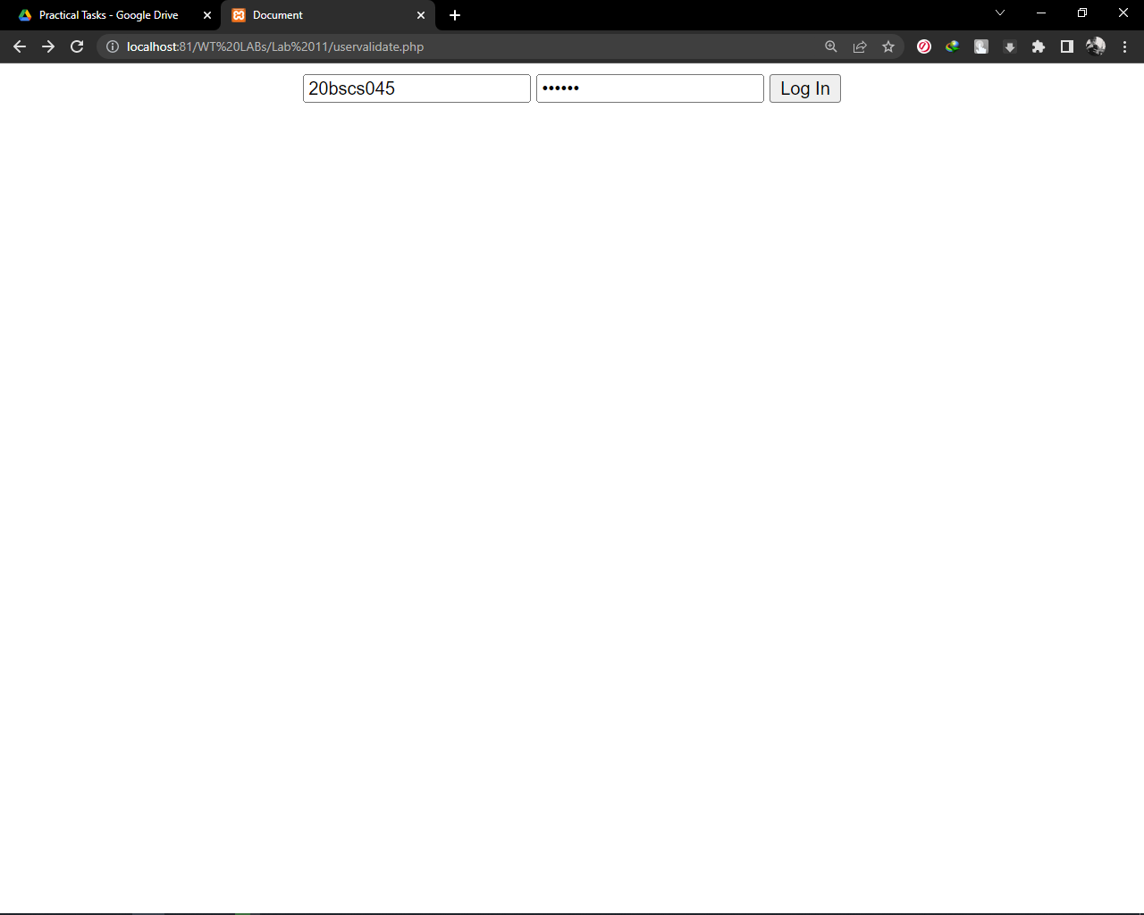

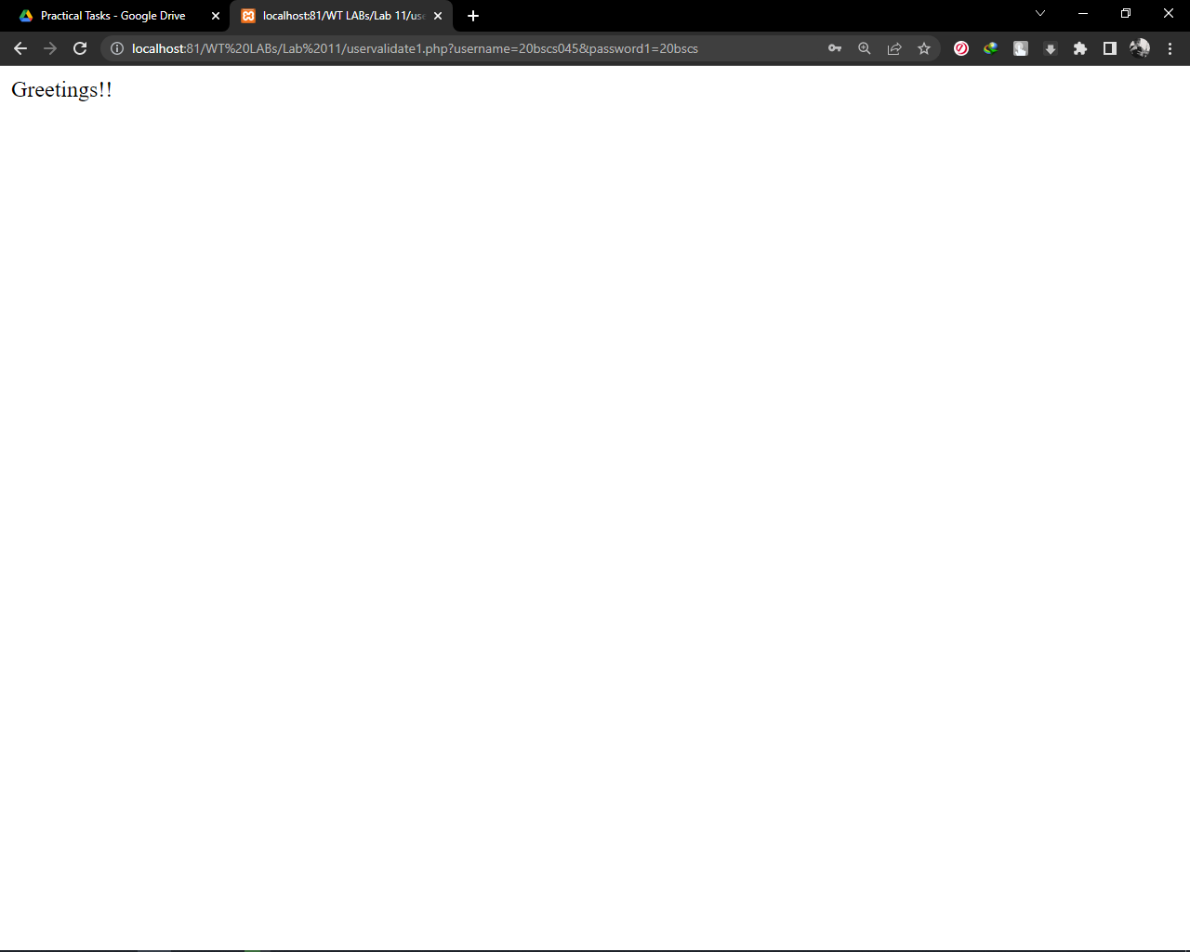

**Task #4:** Write a PHP script that creates the following table using for loops. Add cellpadding="3px" and cellspacing = "0px" to the table tag :

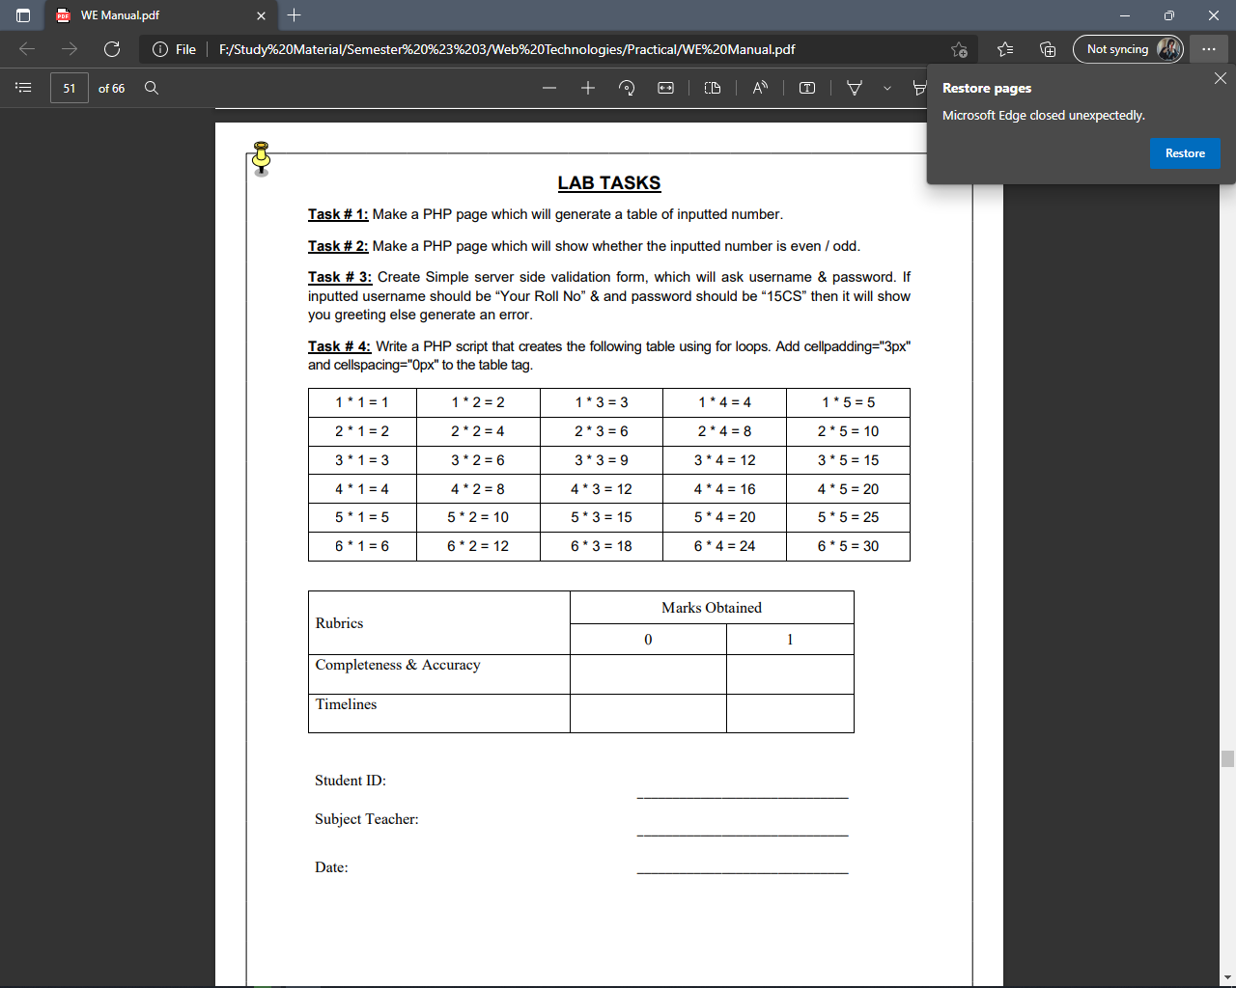

**Code:**

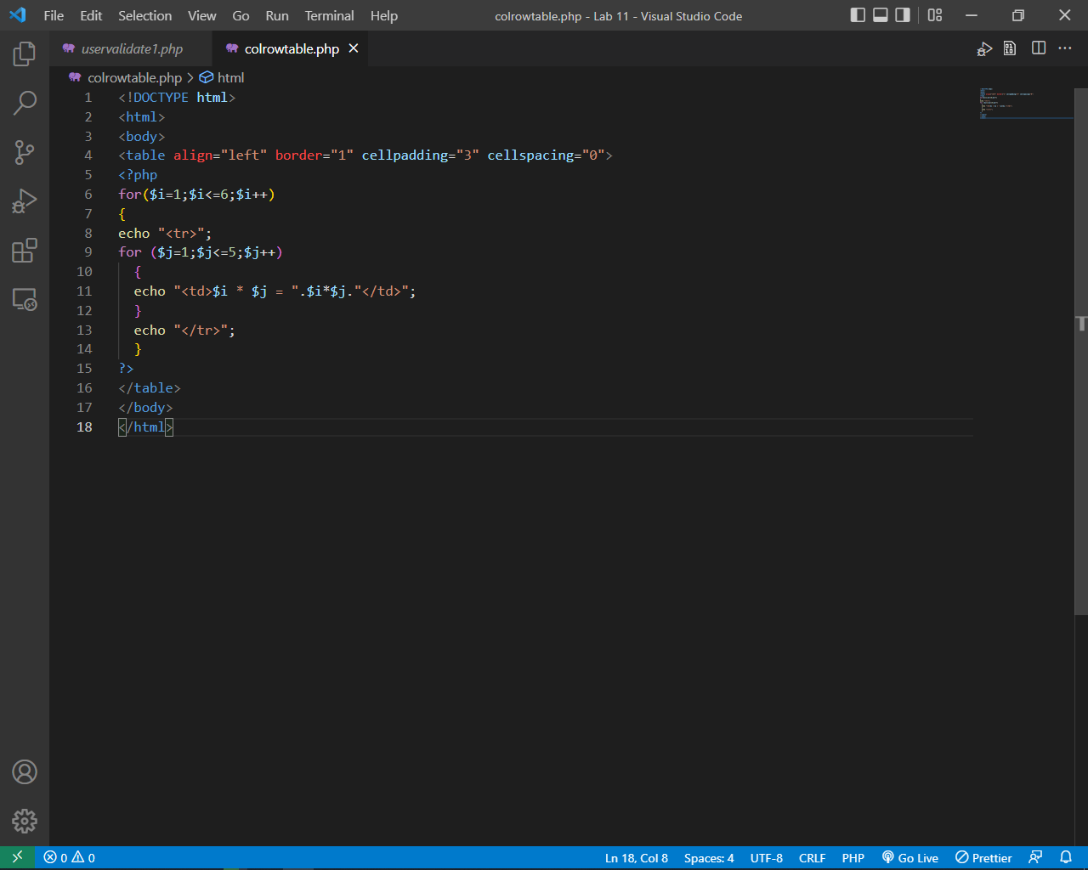

**Output:**

